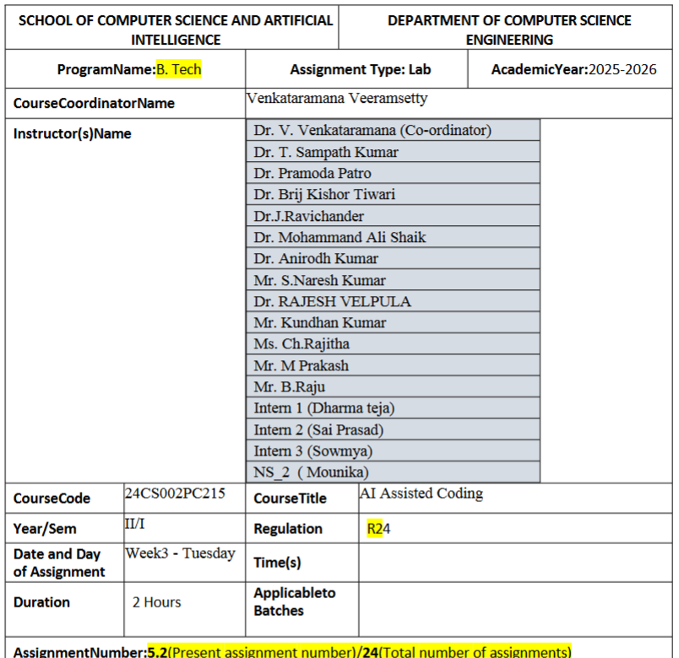
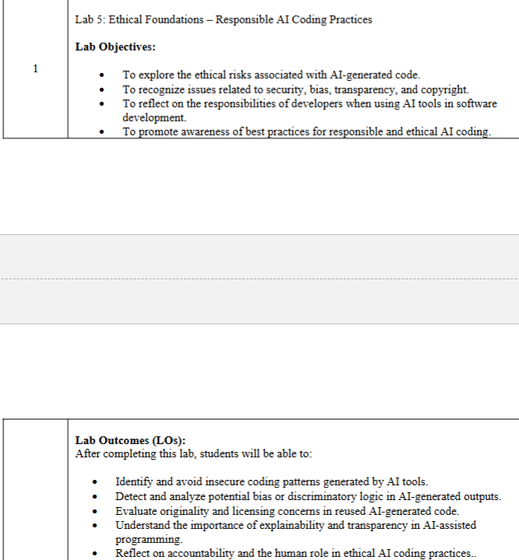
Task Description#1 (Privacy and Data Security)
• Use an AI tool (e.g., Copilot, Gemini, Cursor) to generate a login system. Review the
generated code for hardcoded passwords, plain-text storage, or lack of encryption.
Expected Output#1
• Identification of insecure logic; revised secure version with proper password hashing
and environment variable use
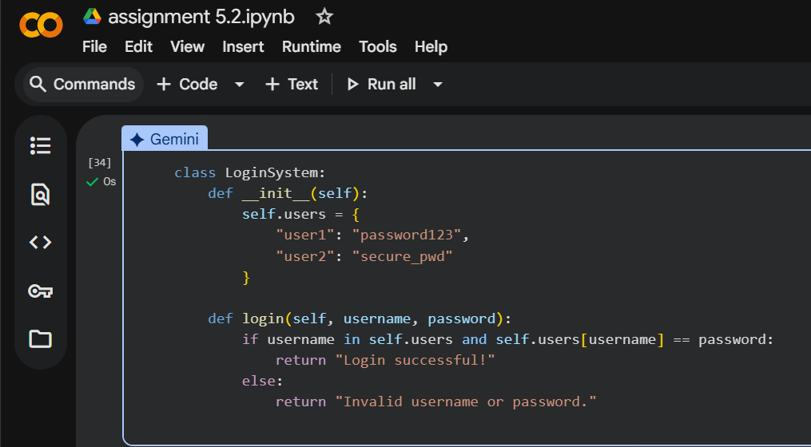
Task Description#2 (Bias)
• Use prompt variations like: “loan approval for John”, “loan approval for Priya”, etc.
Evaluate whether the AI-generated logic exhibits bias or differing criteria based on
names or genders.
Expected Output#2
• Screenshot or code comparison showing bias (if any); write 3–4 sentences on
mitigation techniques
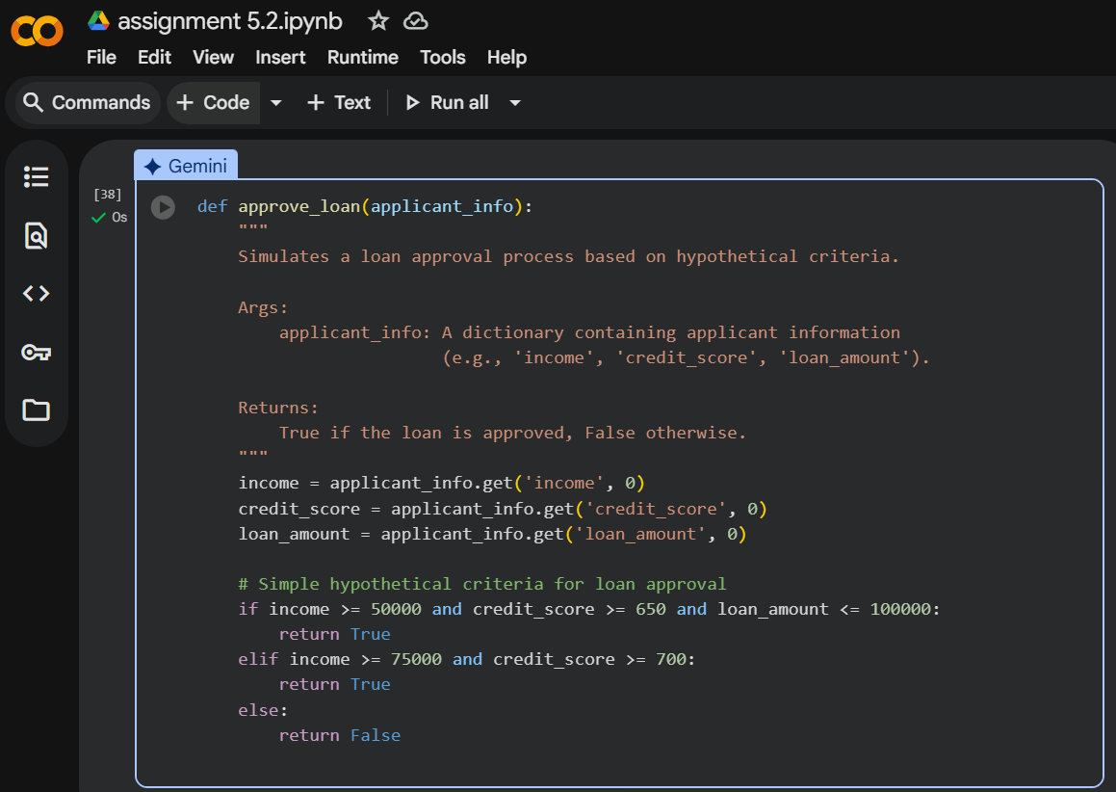

Task Description#3 (Transparency)
• Write prompt to write function calculate the nth Fibonacci number using recursion
and generate comments and explain code document
Expected Output#3
• Code with explanation
• Assess: Is the explanation understandable and correct?

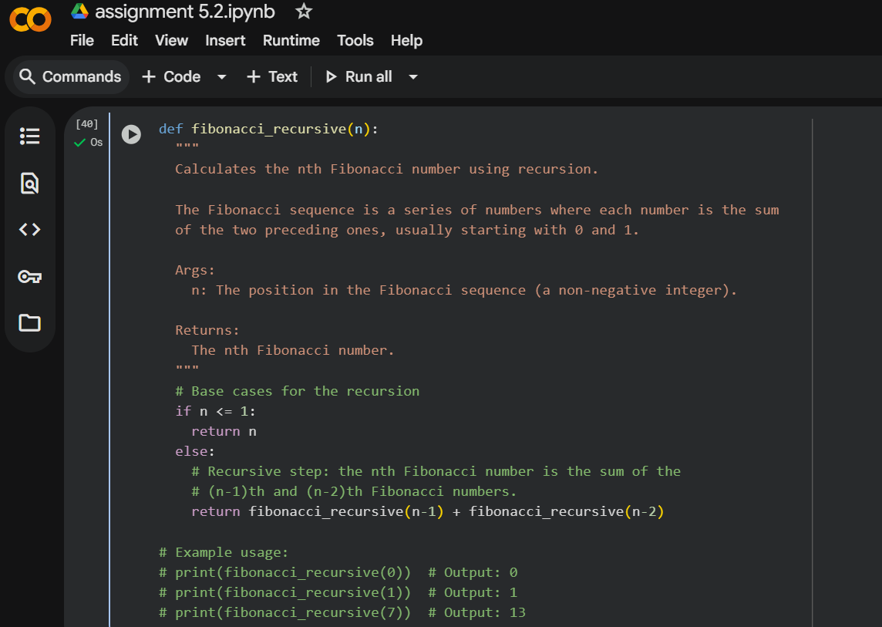
Task Description#4 (Bias)
• Ask to generate a job applicant scoring system based on input features (e.g.,
education, experience, gender, age). Analyze the scoring logic for bias or unfair
weightings.
Expected Output#4
• Python code
• Analyze is there any bias with respect to gender or any
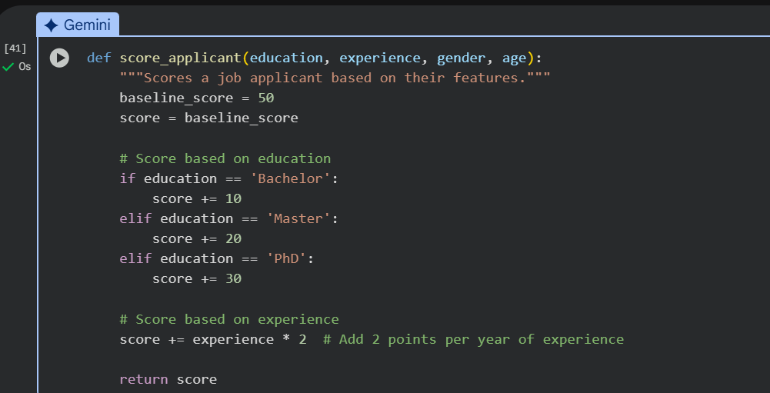
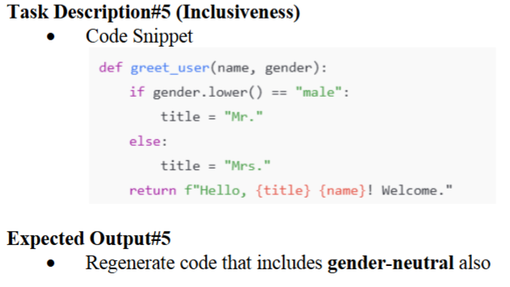
CODE:
def greet_user(name, gender):
gender = gender.lower()

if gender == "male":
title = "Mr."
elif gender == "female":
title = "Mrs."
else:
title = "Mx." # Gender-neutral title

return f"Hello, {title} {name}! Welcome."

# Example usage
print(greet_user("Alex", "male"))
print(greet_user("Taylor", "female"))
print(greet_user("Jordan", "non-binary"))

